**Where to Open a Coffee Shop in Brisbane Australia**

# Introduction

Opening a new coffee shop is a daunting task which can either be a huge success or an abysmal failure. There are numerous reasons why businesses fail in the restaurant industry including price, competition, quality, location, foot traffic to name a few.

# Problem

The problem that will be examined as part of this report will be what suburb is the best for a new business to open a coffee shop in Brisbane, Australia.

# Data

The data to be collected for this report will be the Foursquare location data on all suburbs of Brisbane. This data will be analysed and broken down into the top 10 most popular venues for each postcode. The data will be filtered by criteria to select suburbs that do not have existing coffee shops in their top 10 popular venues to exclude areas with established competitors, the final suburbs will be produced and submitted with recommendations for each area.

# Methodology

## Postcode selection

The approach taken to identify a suitable post code area for a new coffee shop was to first identify all postcodes and suburbs associated with the postcodes for each area in the Brisbane region. This data was taken from the state government website, included the latitude and longitude coordinates and was filtered to include suburbs only listed as “Brisbane” (including Inner-Brisbane, North-Brisbane, South-Brisbane, East-Brisbane, West-Brisbane). This data was uploaded as a CSV file to be used. This data when read from the CSV returned 75 unique postcodes for the Brisbane region.

## Point visualisation

The 75 unique postcodes were then plotted on a map with blue indicators, shown below. Each point represents a postcode that is within the Brisbane catchment. The points shown on Moreton island and north Stradbroke island are shown as they are technically suburbs of the Brisbane region.

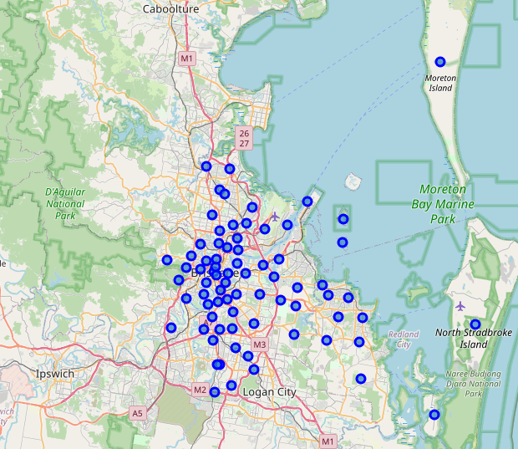

## Venue information

The next step was to extract location and category data for venues within the postcodes to group like venues. The information was gathered using a request to the foursquare API. This resulted in 563 venues which seemed lower that I expected however, Australia seemed to have a lower uptake of foursquare when using the website directly to compare the results. Of note was the fact that the resulting Dataframe only had 64 rows instead of 75 indicating that certain postcodes had no foursquare data. A summary table is shown below.

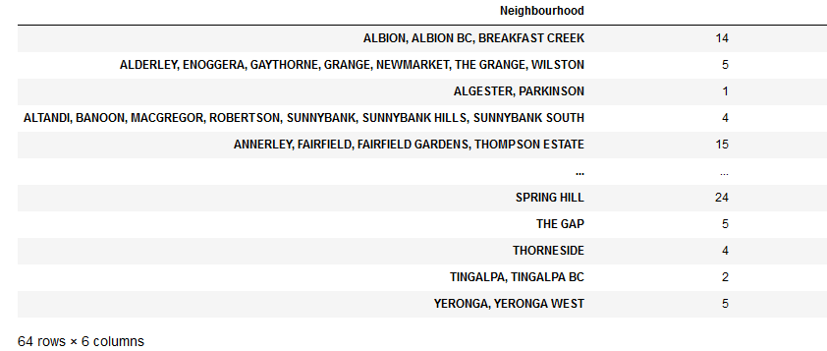

## Data encoding

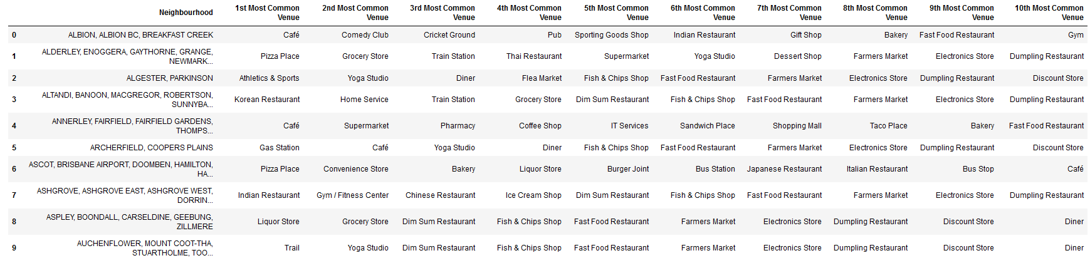The next step was to modify the data to remove categorical values to allow for proper analysis, this was completed using the “one-hot-encoding” method which turned categorical values into numerical values between 0-1. There were 155 possible venue types. Finally, this data was transformed into the 10 most common venue types for each of the 64 postcodes. The first 10 rows are shown below.

# Venue Selection

The next stage was to narrow down the possible locations to open a new coffee shop which will be completed by filtering out the results.

## Filtering – coffee shops

The first step was to review the possible 155 venue types to remove postcodes that already had a coffee shop that was ranked in the top 10 venues. This removes unwanted competition from existing established businesses. The resulting dataframe still has 51 possible postcodes which while less than 64, still provides too many choices.

## Filtering – similar venues

The next step was to filter by similar venue types to coffee shop with the first being Cafés who do the same function as a coffee shop but are categorised differently in the Foursquare data. Removing Cafés and coffee shops reduces the dataframe to 35 possible postcodes which is still too high.

The next round of filtering was for venues that would typically sell products similar to coffee shops. Bakery and Diners were then filtered out resulting in 11 possible locations. This was still too high as the postcodes have multiple suburbs so that choices would be higher than 11.

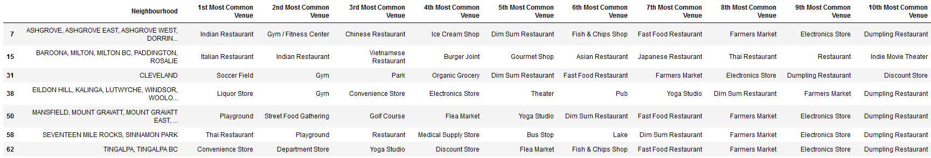An additional filter of grocery stores was also added as they too sell coffee and sweet products similar to a coffee shop. When filtered this resulted in 7 possible locations which is a reasonable list of potential locations.

These 7 locations are plotted on the same Brisbane map.

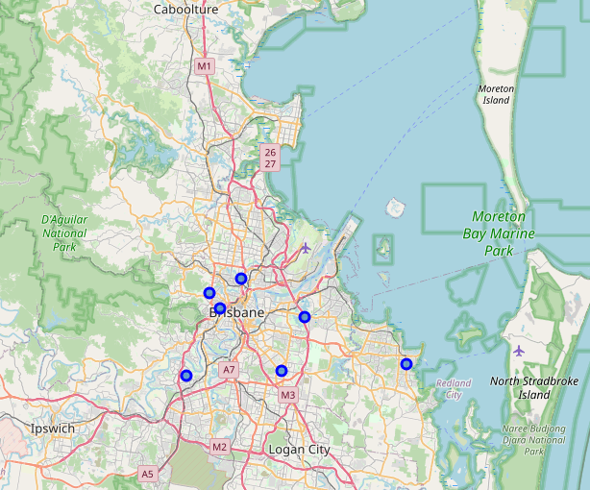

# Results

The overall results paint a clear picture and provide options to potential investors. There were originally five potential suburbs, including Inner-Brisbane, North-Brisbane, South-Brisbane, East-Brisbane, West-Brisbane. The resulting map provides at least one option for each of the five suburbs and two for both North-Brisbane and East-Brisbane. The postcodes can then be further studied to more clearly determine the suitability of a coffee shop in that particular postcode.

# Discussion

Whilst the Foursquare data was easy to obtain and generated a clear map with potential Coffee Shop locations for a new business venture it is also clear that relying on a single source of data does not provide sound business judgement. There are many factors that need to be considered when starting a business and this analysis (while outside the scope of this report) needs to be considered. Example additional data would be real estate data for rents, population demographics including culture for potential customers and their tastes, different data sources to confirm that additional coffee shops are not close by but have not been reviewed using the foursquare app.

# Conclusion

In conclusion the use of the Foursquare API to identify potential coffee shop locations was shown to be useful in getting reviews of various venues within the region selected, the ranking of the venues yielded useful insights into areas that had successful or well-liked coffee businesses. The data analysis and filtering identified seven potential postcodes that did not have a well ranked coffee shop already present and showed potential sites. The data presented is the first step to starting a new business venture and should be considered as such with potential investors taking further steps to narrow down the potential locations within the postcodes and then identify suitable venues that are commercially viable and readily visible to sufficient foot traffic.